Service Resource

📝Definition
# Source: AI Source: Provided by: [Data Path: Persons Table -> ID Column: 1, Name_En Column: Motasem Essam] -> From: [ChatGPT] on [1/23/2026]
A Service Resource is a component that provides reusable business operations or functionality. It acts as a layer between Controllers/ViewModels and Models/Repositories, where the main business logic lives.
👉 Think of a Service as the worker that actually does the job using models and data.

🔑 Key Points
# Source: AI Source: Provided by: [Data Path: Persons Table -> ID Column: 1, Name_En Column: Motasem Essam] -> From: [ChatGPT] on [1/23/2026]
- Contains business logic and operations
- Coordinates between Models, Repositories, and external APIs
- Keeps Controllers and ViewModels clean and thin
- Promotes reusability and testability

🧱 Examples

1️⃣ General Example (Java)
# Source: AI Source: Provided by: [Data Path: Persons Table -> ID Column: 1, Name_En Column: Motasem Essam] -> From: [ChatGPT] on [1/23/2026]
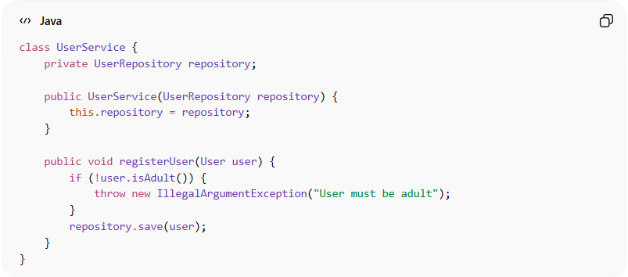
class UserService {
private UserRepository repository;

public UserService(UserRepository repository) {
this.repository = repository;
}

public void registerUser(User user) {
if (!user.isAdult()) {
throw new IllegalArgumentException("User must be adult");
}
repository.save(user);
}
}
👉 Here:
- UserService handles business rules
- Uses User (Model) and UserRepository (data access)

2️⃣ Laravel Example
# Source: AI Source: Provided by: [Data Path: Persons Table -> ID Column: 1, Name_En Column: Motasem Essam] -> From: [ChatGPT] on [1/23/2026]
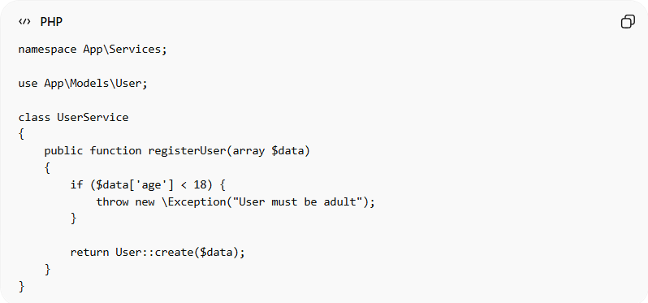
namespace App\Services;

use App\Models\User;

class UserService
{
public function registerUser(array $data)
{
if ($data['age'] < 18) {
throw new \Exception("User must be adult");
}

return User::create($data);
}
}
👉 Here:
- UserService contains business logic
- Uses the User model to interact with DB

❌ Bad Example
# Source: AI Source: Provided by: [Data Path: Persons Table -> ID Column: 1, Name_En Column: Motasem Essam] -> From: [ChatGPT] on [1/23/2026]
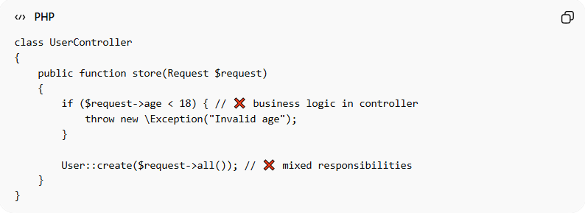
class UserController
{
public function store(Request $request)
{
if ($request->age < 18) { // ❌ business logic in controller
throw new \Exception("Invalid age");
}

User::create($request->all()); // ❌ mixed responsibilities
}
}
Problems:
- Business logic inside Controller
- Hard to reuse and test
- Violates Single Responsibility Principle

✅ Good Example
# Source: AI Source: Provided by: [Data Path: Persons Table -> ID Column: 1, Name_En Column: Motasem Essam] -> From: [ChatGPT] on [1/23/2026]
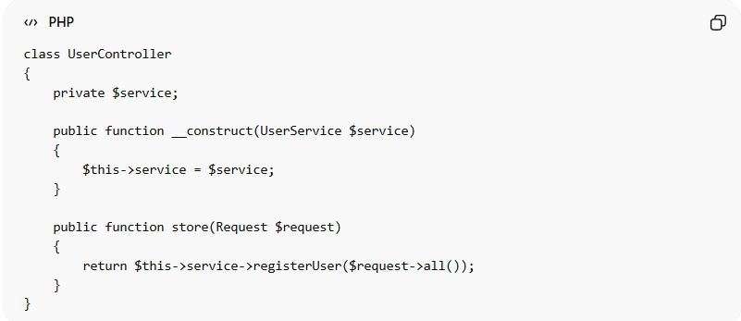
class UserController
{
private $service;

public function __construct(UserService $service)
{
$this->service = $service;
}

public function store(Request $request)
{
return $this->service->registerUser($request->all());
}
}
- Controller is thin
- Service handles business logic
- Easy to test and reuse

🔄 Relation to Other Resources
# Source: AI Source: Provided by: [Data Path: Persons Table -> ID Column: 1, Name_En Column: Motasem Essam] -> From: [ChatGPT] on [1/23/2026]
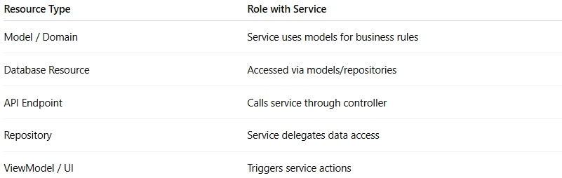
Resource Type | Role with Service
Model / Domain | Service uses models for business rules
Database Resource | Accessed via models/repositories
API Endpoint | Calls service through controller
Repository | Service delegates data access
ViewModel / UI | Triggers service actions

⚠️ Common Mistakes
# Source: AI Source: Provided by: [Data Path: Persons Table -> ID Column: 1, Name_En Column: Motasem Essam] -> From: [ChatGPT] on [1/23/2026]
- Putting UI logic in Service ❌
- Accessing DB directly without abstraction (in complex apps) ❌
- Creating God Services (too large, too many responsibilities) ❌

💡 Key Idea
# Source: AI Source: Provided by: [Data Path: Persons Table -> ID Column: 1, Name_En Column: Motasem Essam] -> From: [ChatGPT] on [1/23/2026]
A Service Resource is where business logic lives, keeping your application clean, reusable, and maintainable.

🧾 Summary
# Source: AI Source: Provided by: [Data Path: Persons Table -> ID Column: 1, Name_En Column: Motasem Essam] -> From: [ChatGPT] on [1/23/2026]
- Handles business operations
- Connects Models, Repositories, and Controllers
- Keeps other layers clean and focused
- Improves testability and structure

